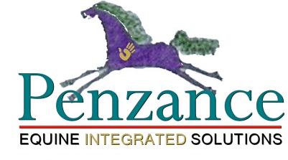
200 South Street Douglas, MA 01516 caballus@charter.net 508.476.1317
ON PENZANCE BODYWORKS™
Gwenyth Browning Jones Santagate
PENZANCE BODYWORKS™ utilizes an intuitive combination based on the studies of the following
neuro-muscular-cellular methods of releasing pain, tension and increasing body awareness:
The Masterson Method™ - is an innovative form of bodywork that relaxes the horse’s body and relieves his muscles, connective tissue, and structure of deep stress and pain.
Through the gentle and light manipulation of targeted Release Points; the movement of joints or junctions through a range of motion in a relaxed state; and studied observation of the horse’s responses (his reactions tell you what he is feeling), you’ll open doors to improved health and performance while enhancing communication—and your relationship—along the way.
Tellington TTouch™ - is a method based on circular movements of the fingers and hands all over the body. The intent of the TTouch is to activate the function of the cells and awaken cellular intelligence - a little like "turning on the electric lights of the body." Using a combination of specific touches lifts, and movement exercises, TTouch helps to release tension and increase body awareness. This allows the animal to be handled without provoking typical fear responses. The animal can then more easily learn new and more appropriate behaviors.
Acupressure – Acupressure balances the body's energy by applying pressure to specific points along energy channels. The term "pressure" is misleading, since acupressure actually uses a very light touch. A practitioner uses her fingertips to make contact with the body. It's the location of the contact that's important, not the amount of pressure. Combining Acupressure with the other bodywork methods allows for targeting specific points on the body on order to facilitate complete relief from stress, muscular tension and pain.
Quantum Touch™ - Quantum-Touch™ is a method of natural healing that works with the Life Force Energy of the body to promote optimal wellness. Life Force Energy, also known as “chi” in Chinese and “prana” in Sanskrit, is the flow of energy that sustains all living beings.
Quantum-Touch teaches us how to focus, amplify, and direct this energy, for a wide range of benefits with surprising and often extraordinary results.
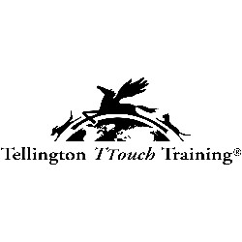
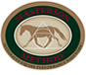
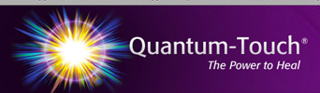
International Association
of Animal Behavioral Consultants

