What Is Operant Conditioning?
Operant conditioning has been a horse training standard and negative reinforcement has been the primary means of shaping behaviors. Horses typically are trained to perform actions in order to avoid something aversive such as moving away from pressure. In positive reinforcement, operant conditioning is achieved by adding a reward to the desired behaviour which allows the animal to perceive some control over the outcome. An example might be a horse learning to knock over a cone to retrieve the food item (reward) from under it.
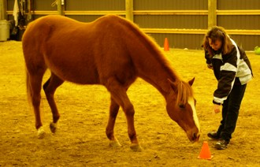
Operant conditioning was coined by behaviorist B.F. Skinner. As a behaviorist, Skinner used the term operant to refer to any "active behavior that operates upon the environment to generate consequences" (1953).
This method of learning occurs through rewards and punishments for behavior. Through operant conditioning, an association is made between a behavior and a consequence for that behavior.

Examples of Operant Conditioning
We can find examples of operant conditioning all around us. Consider the children being asked to complete homework to earn a reward from a parent or teacher, or employees finishing projects to receive praise or promotions.
With horses the same principles apply. What I have found when I use a positive reward system is I obtain more willing and positive results.
In these examples, the promise or possibility of rewards causes an increase in behavior, but it can also be used to decrease a behavior. The removal of an undesirable outcome or the use of punishment can be used to decrease or prevent undesirable behaviors. For example, a child may be told they will lose recess privileges if they talk too loud in class. This potential for punishment may lead to a decrease in disruptive behaviors. With horses I witness an overuse of negative reinforcers which only creates a fearful animal in the end.

Components of Operant Conditioning
Some key concepts in operant conditioning:
A reinforcer is any event that strengthens or increases the behavior it follows. There are two kinds of reinforcers:
1. Positive reinforcers are favorable events or outcomes that are presented after the behavior. In situations that reflect positive reinforcement, a response or behavior is strengthened by the addition of something, such as praise or a direct reward.
2. Negative reinforcers involve the removal of an unfavorable events or outcomes after the display of a behavior. In these situations, a response is strengthened by the removal of something considered unpleasant.
In both of these cases of reinforcement, the behavior increases.

ACHIEVING POSITIVE RESULTS!
A new study conducted by Carol Sankey, MSc,PhD in ethology (the study of animal behavior) proved that horses learn faster and have more positive interactions with humans when they receive food as a reward during training. Yearlings that received grain pellets as compensation for appropriate reactions to vocal commands were up to 40% faster to acquire new skills than a control group of yearlings that received no rewards. Their findings also concluded that force can result in a negative relationship between horses and humans.
Sankey and her team devised a series of objectives that the yearlings in both the reward and the no-reward groups were expected to attain in a consecutive order. After learning to stop and stay by voice command only, each animal learned to wait patiently with the lead line draped over its neck while the trainer brushed it, picked its hooves, attached a surcingle, applied tendon boots, inserted a thermometer in its rectum, and finally applied a "vapor spray" (simulating applying fly spray) over its coat. All eight colts and 15 fillies involved in the study received training individually for five minutes per day, five days per week, until the entire set of objectives was obtained. The amount of time to achieve each task and the totality of the tasks was recorded for both groups.
On average, the reward group finished their training in 3.7 hours whereas the control group needed 5.2 hours to acquire the same tasks. "There wasn't even any overlap," Sankey explained. "The slowest horse in the reward group still learned faster than the fastest horse in the control group."
Additionally, by the end of the training period, horses in the reward group were more likely to voluntarily approach the trainer and to remain at a closer distance to her than the control horses were. Sankey noted that the horses in the reward group displayed more behaviors considered positive by the researchers, including significantly more sniffing, exploration, and licking of the trainer. Horses in the control group were significantly more likely to bite, kick, or fall over during hoof cleaning.
I have started my young yearling Hero down this same path and the results are indisputable! He not only wants to be with me but his level of trust is incredible.

Article Posted with Permission:
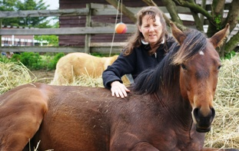 

NOTE FROM PENZANCE: If you’re interested in learning Clicker Training for horses simply email: caballus@charter.net and ask! That’s it … we have several options for e-learning both group studies and privately.

We’ll be presenting some workshops in Grafton, MA this summer 2011 – on just this: CLICKER TRAINING THE HORSE. Please join us!

