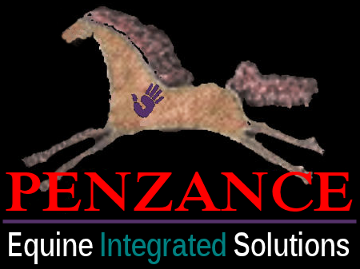 VITAMINS & MINERALS IN BASE LIVE SALAD FOR HORSES
Vitamins and Minerals listed in greater amt. to lesser amount order.
APPLE:
VITS: A, B1, B2, Niacin, Folate, Pantothenic Acid, B6, C, E, K and small amts. of other vitamins.
MINS: Potassium, Calcium, Phosphorus, Magnesium, Manganese, Iron, Sodium Copper, Zinc and trace amts. of other mins.

AVOCADO:
VITS: A, C, B1, B2, Niacin, Folate, Pantothenic Acid, B6, E, K.
MINS: Potassium, Phosphorus, Magnesium, Calcium, Sodium, Iron, Selenium, Manganese, Copper, Zinc.

ORANGE:
VITS: A, B1, B2, Niacin, Folate, Pantothenic Acid, B6, C, E.
MINS: Potassium, Phosphorus, Magnesium, Calcium, Iron, Selenium, Manganese, Copper, Zinc.

BANANA:
VITS:: A, B1, B2, Niacin, Folate, Pantothenic Acid, B6, C, E, K
MINS:: Potassium, Phosphorus, Magnesium, Calcium, Sodium, Iron, Selenium, Maganese, Copper, Zinc.

CARROTS:
VITS: A, C, B1, B2, Niacin, Folate, Pantothenic Acid, B6, K, E.
MINS Potassium, Calcium, Phosphorus, Magnesium, Iron, Sodium, Zinc, Copper, Manganese, Selenium

SWEET POTATOES: (Yams)
VITS: C, Niacin, B1, B2, B6, Pantothenic Acid, Folate, A, K, E.
MINS: Potassium, Phosphorus, Magnesium, Calcium, Sodium, Iron, Selenium, Manganese, Zinc, Copper

SPINACH:
VITS: C, Niacin, B1, B2, B6, Pantothenic Acid, Folate, A, K, E
MINS: Potassium, Phosphorus, Magnesium, Calcium, Iron, Sodium, Zinc, Copper, Manganese, Selenium

KALE:
VITS: A, C Niacin, B1, B2, B6, Folate, Pantothenic Acid, K, E
MINS: Potassium, Phosphorus, Magnesium, Calcium, Iron, Sodium, Zinc, Copper, Manganese, Selenium
http://www.healthalternatives2000.com

